NAVVIS CoreoView

User’s Guide

December 2019

Document Version 1.00



Navvis & Company is a solutions firm assisting physicians and health networks with health management

Real Life.

Life Changing.

Changing Healthcare.

NAVVIS CoreoView user's guide release 1.00.

Copyright © 2019 NAVVIS & Company, LLC. All rights reserved.

Sample names and persons used in this document are purely fictitious and do not refer to real names or persons.

This user's guide has been created with utmost care, nevertheless, it is not guaranteed that this document is error free.

No part of this document may be reproduced or transmitted in any form or by any means, electronic or mechanical, for any purpose, without the express written approval of Navvis & Company.

Table of Contents

Preface 1

1 Introduction 2

2 User login process 2

3 Settings and user management for CoreoView 2

3.1 Create care groups 2

3.2 Set up locations 4

3.3 Create user roles 4

3.4 Manage user access and permissions 6

3.5 Set up users 8

3.6 Manage user rosters 8

3.7 Manage patient cohorts 8

4 Creating and assigning beds 8

4.1 Create a new bed 8

4.2 Assign a patient to a bed 8

4.3 View patient summary 8

4.4 Modify bed details 8

4.5 Delete a bed 8

5 Processing patient-move request 8

5.1 Process a request move 8

5.2 Process a quick move 8

5.3 Move the patient across facilities 8

6 Viewing modes 8

6.1 Manage information through bed board view 8

6.2 Manage information through prioritized view 8

6.3 Manage information through geo-map view 8

7 Applying filters 8

7.1 Select filter criteria 8

7.2 Add or remove filters from a view 8

8 Viewing themes based on beds, locations and patients 8

8.1 View default themes 9

8.2 Activate a theme 9

8.3 Modify a theme based on the filter 9

8.4 Save a theme 9

9 Generating Reports 9

9.1 Print facility reports 9

9.2 Print audit logs 9

9.3 Print automation logs 9

10 Appendices 10

11 Glossary 11

12 Index 12

Preface

Welcome to the release of the NAVVIS CoreoView user’s guide.

This user’s guide covers the information to use the CoreoView application effectively.

It contains detailed information about the following features:

Introduction

This topic gives a brief overview of the CoreoView application.

The user login process

Settings and user management for CoreoView

This topic covers the user management settings for CoreoView. It details how to set up hospital facilities, locations, users, user roles, user permissions to use the features, user roasters and patient cohorts.

Creating and assigning beds

Processing patient-move request

Viewing modes

Applying filters

Viewing themes based on beds, locations and patients

Generating reports

This preface explains how this user’s guide is organized.

Introduction

Navvis & Company provides counsel to health systems, hospitals and physician groups on the development of innovative, market-linked strategies to build future-ready health systems, cultivate tomorrow’s leaders and strengthen strategic performance.

Navvis, a real-person care company, under the brand name CoreoView offers its software application as a solution to manage population health.

Population health aims at improving the overall health of a defined group of population. This is achieved through quality care, cost management, and having pro-active approaches towards wellness for that defined group of population.

CoreoView is HIPAA (Health Insurance Portability and Accountability Act) compliant and is available as SaaS (Software-as-a-Service) cloud solution enabling management of patients with real-time data.

CoreoView software application empowers users to manage the status and flow of patients through locations within Acute Care (AC), Post-Acute Care (PAC) networks and Cross-Continuum (CC).

Starting CoreoView and logging in

CoreoView application is available on desktops, laptops, IOS mobile devices and android mobile devices.

CoreoView allows its users to access its platform when the user registers with a new account.

A first-time user is required to sign the EULA (End User License and Business Associate Agreement) before logging into the application.

EULA is a binding legal agreement between Hawaii’s Medical Service Association (HMSA) and the user.

Start the CoreoView application

Follow these steps to start the CoreoView application:

Double-click the CoreoView icon on the desktop or a laptop, or tap the CoreoView app icon on a mobile device to start the application.

The EULA screen displays for a first-time user.

Read the terms and conditions and select the **I agree** check box.

The **NAVVIS Sign in** screen displays.

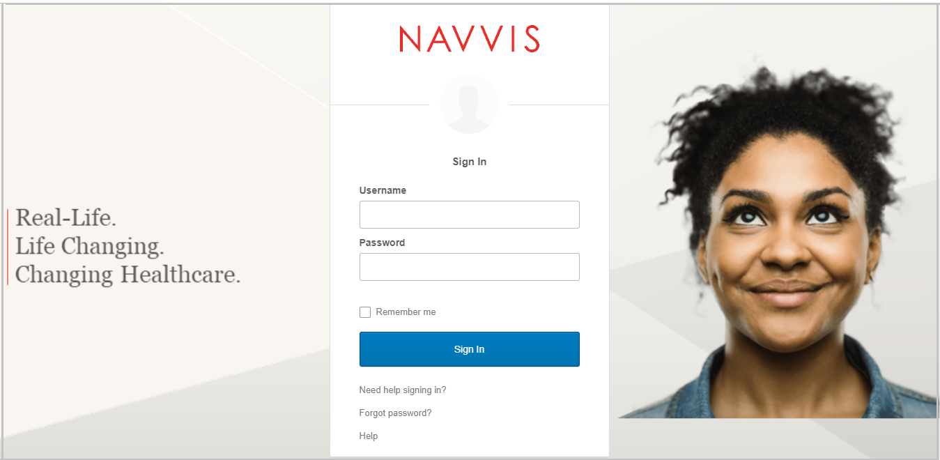

1. Sign In screen

Log into the application

The user is give a user identification and a password to log into the application.

Follow these steps to log into CoreoView.

Enter the user identification in the **Username** box.

Enter the password in the **Password** box.

Settings and user management for CoreoView

The user management settings for CoreoView is set up by creating hospital groups, locations, users, user roles, user permissions to use the features, user roasters and patient cohorts.

Create care groups

The CoreoView application provides the following three groups to categorize patients based on the care facilities that they are provided with.

1. Acute care: Acute care group includes emergency department, intensive care, coronary care, cardiology, neonatal intensive care and so on.
2. Post-Acute Care (PAC) network: Under this care group, patients are cared with skilled nursing facilities, inpatient rehabilitation facilities, long-term acute hospital facilities among others.
3. Cross continuum: Under this care group, patients are cared at their home locations and are served by home-health and outpatient services.

Follow these steps to create a new group in the CoreoView application:

1. Click the **Settings** menu in the left pane on the CoreoView home page.
2. Click the **Add** button under the **Groups** tab. The **Add Group** tab page opens.
3. Select the type of group from the following options:

* **Acute Care**
* **Post-Acute Care Network**
* **Cross Continuum**

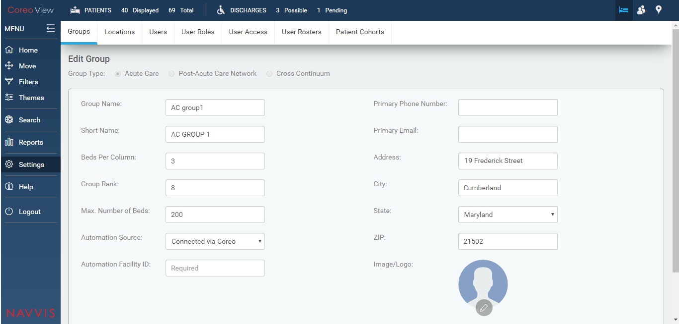

1. Groups tab page

For the **Acute Care group** type, enter the following details:

1. Enter the acute care group name in the **Group Name:** field.
2. Enter a short name for the acute care group in the **Short Name:** field.
3. View the number of beds allotted for each column for this group in the **Beds Per Column:** field. You can modify this value.
4. View the group rank in the **Group Rank:** field. The user can modify this value.
5. View the maximum number of beds that is available for this care group in the **Max. Number of Beds:** field.
6. Select the automation source in the **Automation Source:** field from the following options:

* **Connected via Coreo**
* **None**

1. Enter the primary phone number of the care group in the **Primary Phone Number:** field.
2. Enter the primary email address of the care group in the **Primary Email:** field.
3. Enter the address details of the care group in the **Address:** field.
4. Enter the name of the city in which the care group is located in the **City:** field.
5. Select the **State:** arrow to view the states in the U.S region and then select the name of the state in the **State**: field.
6. Enter the ZIP code of the region that the care group belongs to in the **ZIP:** field.
7. Select the **Save** button to changes.

Set up locations

Create user roles

The CoreoView application provides its users with role based permissions to its features.

The roles could include the following:

Administrator super user

Administrator

Hospital administrator

Hospital nurses / Care giver roles

Hospital non-clinical roles

Hospital role types - Care giver roles and Non-clinical roles

PAC (Post-Acute Care) role types – PAC site admin, Care giver roles and Non-clinical/EVF roles

CC (Cross Continuum) – CC site admin, Care giver roles and Non-clinical/EVF roles

Follow these steps to create user roles on the **User Role Management** page.

On the **CoreoView** homepage, go to the **Settings** menu in the left pane.

Go to the **User** **Roles** tab to open the **User Role Management** page.

Select the **Add** button.

Enter the name of the user role in the **Name:** field.

Enter a description for the user role in the **Description:** field.

Enter the feature in the **Access Rights:** search box to grant the permission for and click the **Search** button. The features under the available permissions are displayed based on the search key word.

Select the appropriate features under **Available permissions** to give permissions to the user role.

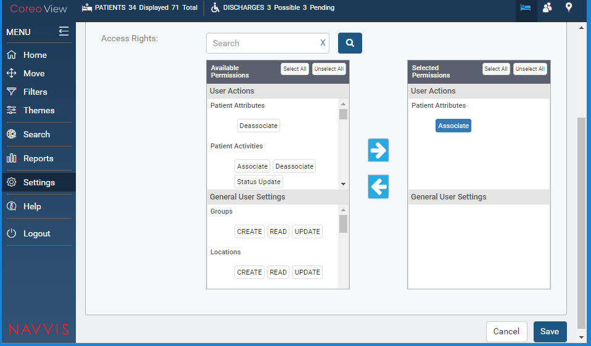

1. Available Permissions For User Roles

Select the **Select All** button and then click the right arrow button to move the permissions under **Selected** **Permissions**.

The available permission for the user role is detailed in the tabular column below:

| User Actions | |
| --- | --- |
| Features | Permissions |
| Patient Attributes | Associate, Deassociate |
| Patient Activities | Associate, Deassociate, Status Update |
| Bed Attributes | Associate, Deassociate |
| Bed Cleaning | Cleaning Required, Cleaning Complete |
| Move/Assign Patient | Request Move, Assign Patient, Accept Move, Reject Move, Cancel Move, Quick Move |
| Providers & LOS | Length of Stay |
| Patient Disposition | Observation, Admitted, Discharge Possible, Discharge Pending, Discharge Complete, Emergency |
| Patients | READ, UPDATE, DELETE |
| Audit Trail Reports | READ, Download |
| Reports | READ, Download |
| Automation Logs | READ, UPDATE |
| Move/Transfer Patient | Transfer Patient |
| Cohort Management | Bulk Assign |
| Notifications | Roster Updates |
| General User Settings | |
| Features | Permissions |
| Groups | CREATE, READ, UPDATE |
| Locations | CREATE, READ, UPDATE |
| Beds | CREATE, READ, UPDATE, DELETE |
| Users | CREATE, READ, UPDATE, DELETE |
| User Roles | CREATE, READ, UPDATE |
| User Access | CREATE, READ, UPDATE |
| Rosters | CREATE, READ, UPDATE |
| Cohorts | READ, UPDATE |

Table X-X: Available permissions for the user roles

Click **Save** to save the user role permissions.

View the newly created user role on the **User Role Management** page.

Manage user access and permissions

Follow these steps to create user roles on the **User Access Management** page.

1. On the **CoreoView** homepage, go to the **Settings** menu in the left pane.
2. Go to the **User** **Roles** tab to open the **User Role Management** page.
3. Select the **Add** button to add new user access on the **Add User Access** page.

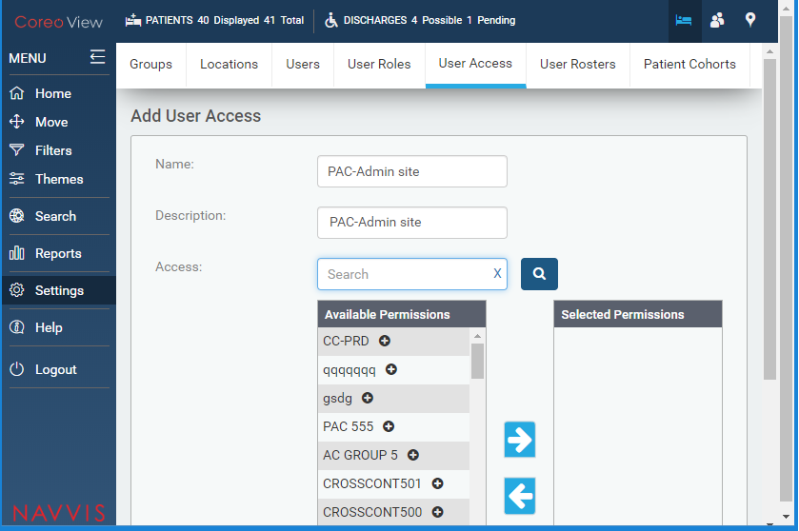

1. Add Users Access Tab Page
2. Enter the user access name in the **Name** field.
3. Enter a description for the user access in the **Description:** field.
4. Enter the group in the **Access:** search box to grant the permission for and then click the **Search** button. The groups under the available permissions are displayed based on the search key word.
5. Select the appropriate group under **Available permissions** to give permissions to the user.
6. Select the right arrow button to move the selected group under **Selected** **Permissions**.
7. Click **Save** to save the user access permissions.
8. View the user access details on the **User Access Management** page.

Set up users

Manage user rosters

Manage patient cohorts

Creating and assigning beds

Create a new bed

Assign a patient to a bed

View patient summary

Modify bed details

Delete a bed

Processing patient-move request

Process a request move

Process a quick move

Move the patient across facilities

Viewing modes

Manage information through bed board view

Manage information through prioritized view

Manage information through geo-map view

Applying filters

Select filter criteria

Add or remove filters from a view

Viewing themes based on beds, locations and patients

View default themes

Activate a theme

Modify a theme based on the filter

Save a theme

Generating Reports

Print facility reports

Print audit logs

Print automation logs

Appendices

References section:

[www.bloomberg.com/profile/company/3553499Z:US](http://www.bloomberg.com/profile/company/3553499Z:US)

[www.navvishealthcare.com/](http://www.navvishealthcare.com/)

[www.linkedin.com/company/navvishealthcare](http://www.linkedin.com/company/navvishealthcare)

[www.pitchbook.com/profiles/company/88126-75](http://www.pitchbook.com/profiles/company/88126-75)

[www.crunchbase.com/organization/navvis-company](http://www.crunchbase.com/organization/navvis-company)

[www.healthcareitnews.com/blog/defining-population-health](http://www.healthcareitnews.com/blog/defining-population-health)

[Appendices are optional, and are used to provide additional detailed information that may help the end user manage the overall application. Examples could include references to standards (such as W3C standards), technical specifications required for regulatory compliance, checklists, or other information of a technical nature.]

Glossary

[Glossary term – Description]

[Glossary term – Description]

[Glossary term – Description]

[Glossary term – Description]

[Glossary term – Description]

……………………..

Index

[Depending on the size or complexity of the final document, insert an index to assist the user in locating specific information. Index entries correspond to tags or categories, and are useful in navigating long books.]

[Index term – *page number*]

[Index term – *page number*]

[Index term – *page number*]

[Index term – *page number*]

[Index term – *page number*]